**MINDZ TECHNOLOGY**

**BLUE COLLAR MODULE**

**Software Requirement Specification**

# 

# Introduction

Blue Collar services are manpower services to other members of the system. Through Blue Collar members can hire Drivers, Cleaners, Skilled & Semi skilled.

# Business Process

Business Rule – Franchisee will have access to Blue Collar as a seller.

Blue Collar services are manpower services to other members of the system. Through Blue Collar members can hire Drivers, Cleaners, Skilled & Semi skilled.

* 1. Franchisee can on board Blue collar members
  2. Registration for each type of Blue Collar worker will be different.

**Blue Collar Registration:**

Blue Collar will be managed by the Franchisees. Franchisees will have access to blue collar services as a seller. Only Blue Collar can be accessed by Franchisees in the market place.

* For Blue Collar there is no subscription fee as a Seller.

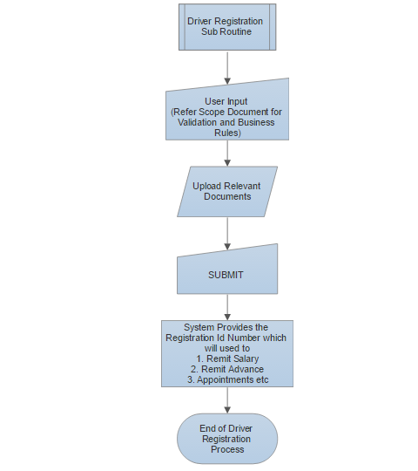

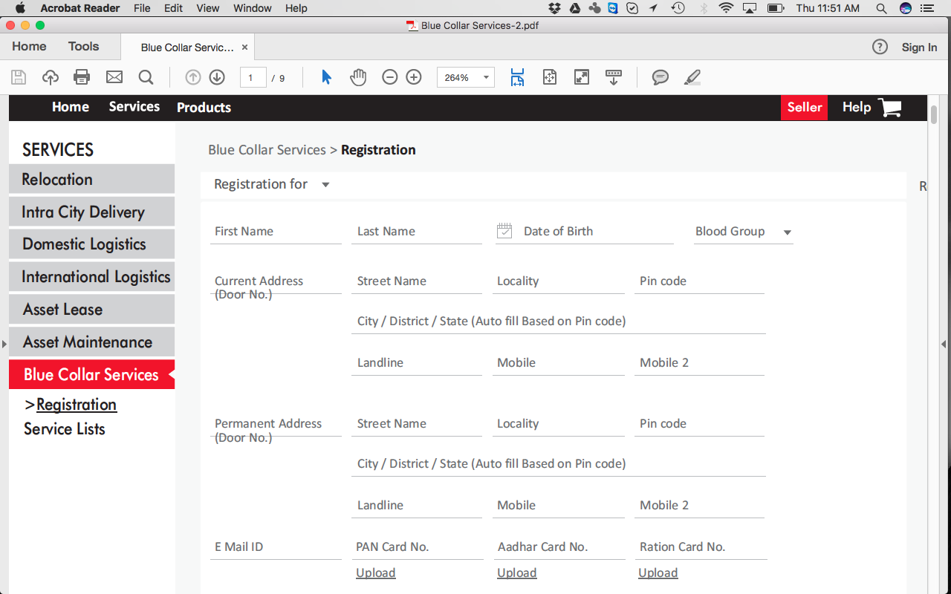

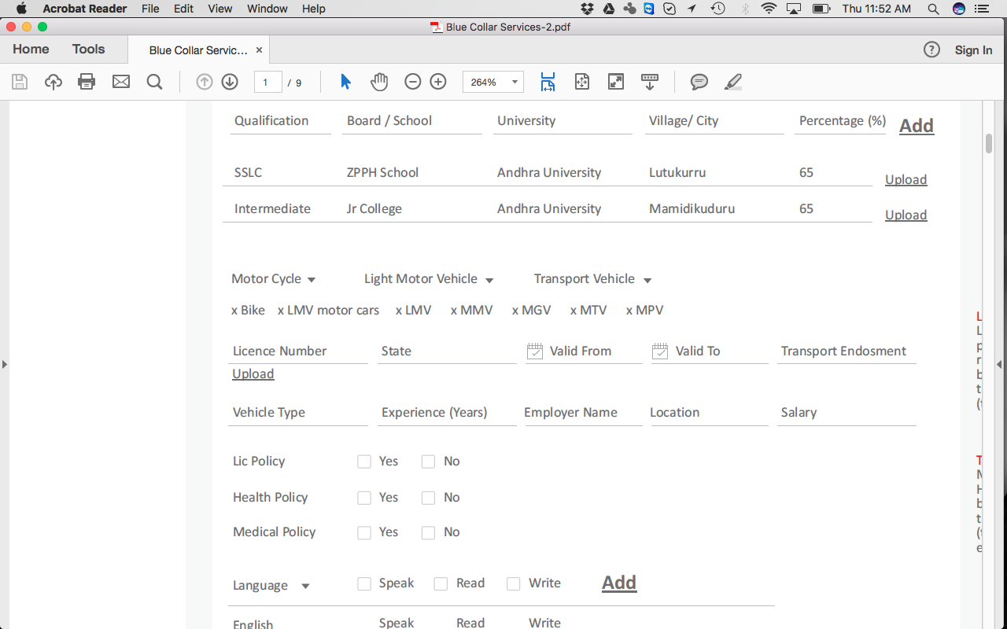

1. Verification is done subsequently

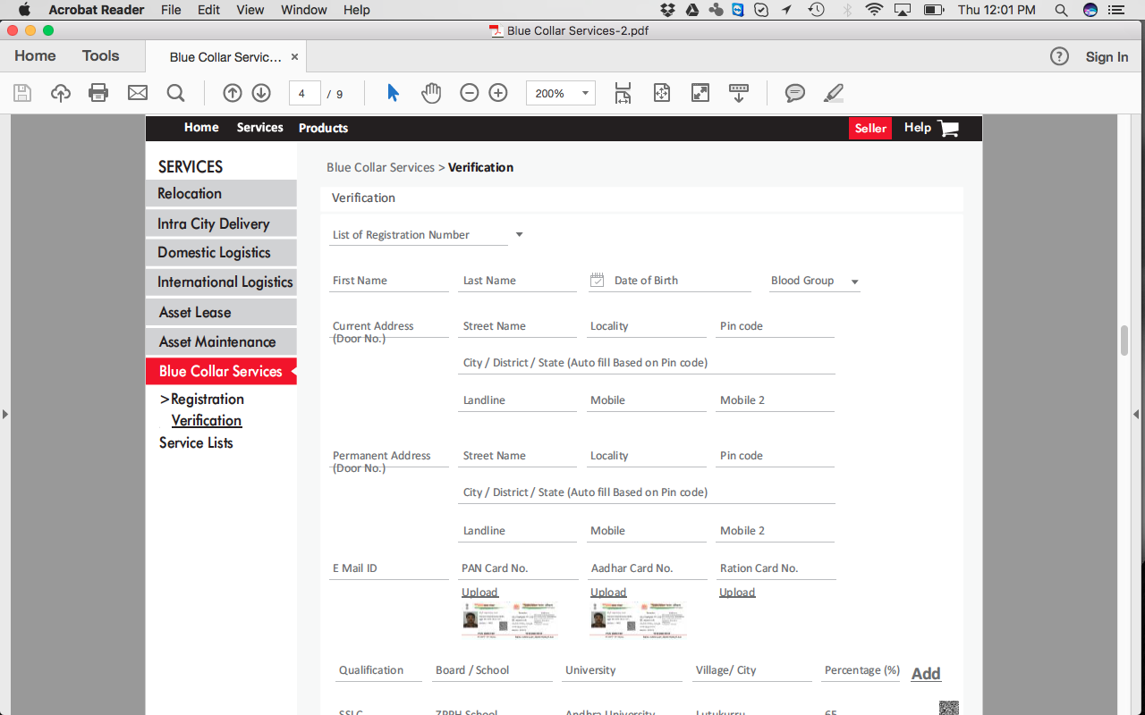

1. Upon verification, Blue Collar members can log into the system and update their profile
2. They can search for employment posted by various others members of Logistiks
3. **Buyer Search**
   1. Buyers can search of blue collar workers by
      1. Type
      2. Location
      3. Vehicle type (multiple types can be chosen)
      4. Employment type
         1. Contract
         2. Permanent
      5. Experience
      6. Salary Type

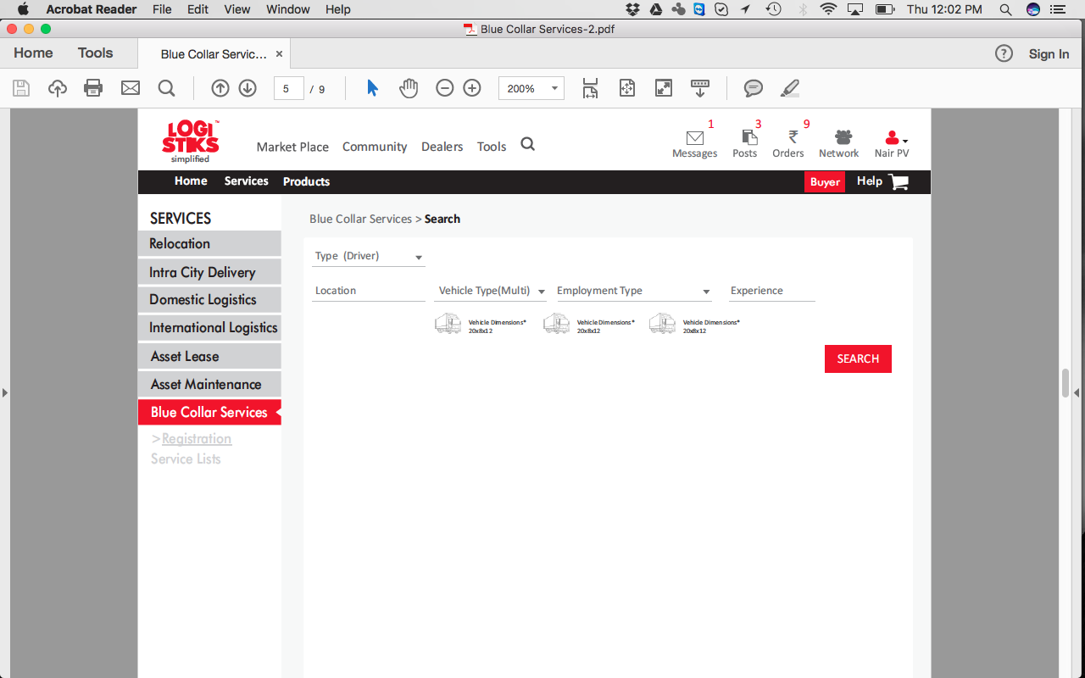

1. **Buyer Search Results**
   1. Search results display the matched Blue collar workers
   2. Buyer can choose to shortlist the candidate for an interview

**BUYER’S SEARCH:**

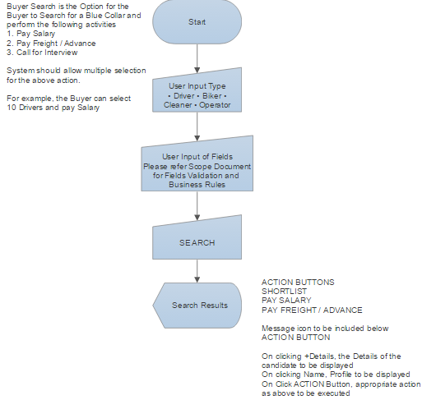

* Repeat similar Process for Driver /Cleaner / Skilled /Semi skilled operator

**SELLER’S SEARCH:**

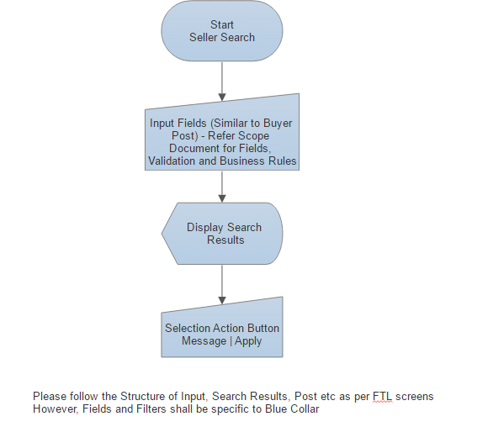

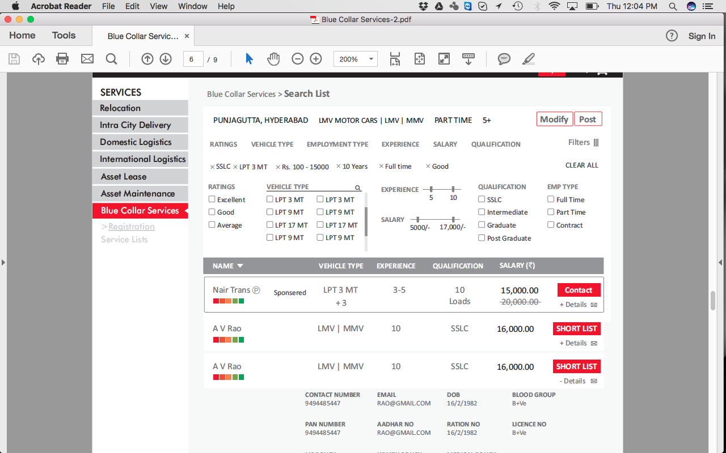

1. **Buyer post & get quote**
   1. Buyer can also post his requirements
   2. Buyer can post for multiple positions
      1. Type
      2. Location
      3. Vehicle type (multiple types can be chosen)
      4. Employment type
         1. Contract
         2. Permanent
      5. Experience
      6. Salary Type or salary range
      7. Price Type (Competitive /Fixed).
      8. Qualification (drop down from blue collar master)
      9. Buyer post list add button - Profile Type, Experience, Salary, Qualification.

NOTE: Add button should be there for adding another resource.

1. Post Master
2. Seller rate card: This is the same as seller registration since he provides details of his salary
3. Seller search - **give details**
4. Buyer book now
5. Seller quote
6. Buyer GSA
7. Seller GSA
8. Buyer pay online